**Tutorial 9 AVL, Threaded ( Q1 –Q7 ) ( week 10-15 Oct 2022)**

**Tutorial 10 RB, B, B+ (Q 8 – Q 11 ( week 17-22 Oct 2022 )**

1. Construct an AVL tree using the following

Tree1 with sequence of data: 10, 5, 3, -1, 7, 9, 8 , 2, 1

and Tree 2 with 21,26,30,9,4,14,28,18,15,10,2,3,7

1. Find successor of a given node in Threaded binary tree. Write a function for inorder traversal without using stack or recursion.
2. Find predecessor of a given node in Threaded binary tree. Write a function for preorder traversal without using stack or recursion.

4)

* 1. Given is a Threaded BST in below Figure. Write step by step explanation of traversals:

1. inorder
2. postorder
3. preorder

II. Insert 26, 28, 39, 2, 22 , 19, 32, 5, 0

III. Delete 2, 24, 11, 39, 0, 30

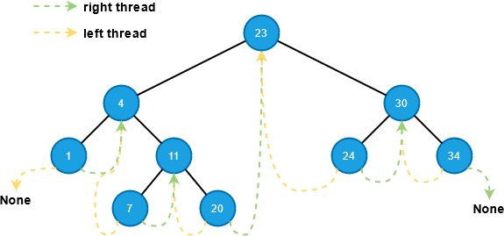

1. Convert below BST to a Threaded BST and then perform all the traversals

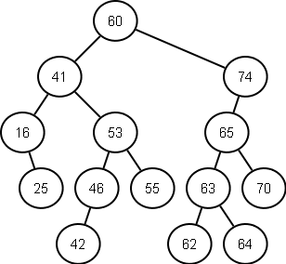

1. Consider a sorted list of 10 values and suggest the sequence of insertion in to an AVL tree such that there is no rotation required for it.
2. Finding an element in BST is faster as compared with find the element in an AVL tree. Justify.
3. Construct a B-Tree of order=3 using the data R,Y,F,X,A,M,C,D,E,T,H,V,L,W,G.

# Construct a B+Tree of order=3 using the data given in above question

1. What are the advantages of using B+tree over B-Tree.

# Create an RB Tree by inserting the nodes in following sequence: 20,30,40,50,60,70,80,90,100,110,120,130

Now perform Deletions in sequence

# 130, 80, 60, 20, 100, 60, 110, 70, 30, 120